PARTNER COMMS TOOLKIT

Hi there!
This toolkit is designed for partners to help with your organisation’s sustainability campaigns and goals . It contains useful info, copy, links, tips and graphics to help inform your colleagues, followers and audiences about the Impact Score Shopping app. And how it can help them make small, sustainable changes to their shopping habits, and make a real difference to people and the planet.
Please contact us at any time at hello@impactscore.app - we’d love to hear from you.
Cheers!
Josh | Impact Score® Co-Founder

Contents
1. GRAPHICS, IMAGES & LOGOS SUITE 2
2. SUGGESTED COPY FOR COMMS 2
3. PROMOTING ACTION THROUGH CAMPAIGNS – SOME EXAMPLES 3
4. SOCIAL MEDIA HANDLES 4
5. BLOGS FOR USE 5
6. PRESS COVERAGE 5

1. GRAPHICS, IMAGES & LOGOS SUITE
Here is a suite of Impact Score graphics, images and logos you can use in your communications. Click here>

2. SUGGESTED COPY FOR COMMS
We’ve pulled together this blurb for you to use across your communications channels - newsletters, emails, articles, websites. To show your audiences how you are taking action on sustainability. Feel free to personalise it to your organisation but do let us know you are using it.
Did you know 23% of your carbon footprint comes from the products you buy from supermarkets? So making small adjustments to your buying decisions can make a big difference! That’s why we’re always on the lookout for new innovative tech that helps us live more sustainable, healthier lives. We recently came across a mobile app that does just that…

Because ‘sustainability’ means different things to different people., the Impact Score Shopping app rates the thousands of everyday supermarket products for sustainability credentials that people care about, like recyclable packaging, animal welfare, nutrition, carbon footprint and workers’ rights.
How does it work? Well, you simply scan the barcode or search the name of any supermarket product, and discover which of the 14 sustainability badges the product is awarded. You are then offered more sustainable alternatives to consider swapping out your product for.

The team at Impact Score® work with more than 30 expert organisations like WWF, the NHS, Fairtrade, and Breast Cancer UK, to ensure their product ratings are fair and accurate. And the ratings are being validated by The University of Chester too.

As the team at Impact Score® say, every purchase you make can bring about positive, sustainable and social change. So let’s start finding those better products and sharing them with your friends!

Action!
Learn more and download the app here: https://www.impactscore.app/shoppers/Oh and watch this space for more updates on this - we’ll be collaborating with Impact Score® on a range of campaigns we have planned next year.

3. PROMOTING ACTION THROUGH CAMPAIGNS – SOME EXAMPLES
We work with partners like the University of Manchester and Exmoor Zoo to help support their staff, students and customers make daily adjustments to be more sustainable. Here is some copy you can use and tweak to encourage your audiences to get involved in taking their own personal sustainability actions. Please contact the team if you want any more ideas or comms support:
Taking Action through Campaigns
We can all make small changes to our daily routines that reduces our impact on the environment, people and the planet. But it’s really difficult to make those changes if we haven’t got clear instructions on what actually makes an impact. The team at Impact Score® have developed a series of tangible actions anyone can make:

- Example Campaign 1 - Scan, swap, share!
Download the Impact Score Shopping app and scan a product, swap it for a better alternative, and share your thoughts and actions on social media [tagging @impactscoreapp and @[your organisation]
- Example Campaign 2 - It’s Veganuary!
Download the Impact Score Shopping app, scan 5 food products in your house, and check out how many get ‘Plant-Based’ badges. Consider buying the alternative product suggestions next time you shop.
- Example Campaign 3 - Reduce your carbon!
Download the Impact Score Shopping app, scan 5 food products in your house, and check out how many get ‘Low Carbon Footprint’ badge. Consider buying the alternative product suggestions next time.

- Example Campaign 4 - Eat healthy!
Download the Impact Score Shopping app, scan 5 food products in your house, and check out how many get ‘Healthier Option’ badges. Consider buying the alternative product suggestions next time.

- Example Campaign 5 – Find the hero!
Of all the 280,000 supermarket products rated by Impact Score, less than 3% are a ‘hero’ product (the most sustainable and/or healthy products). Download the Impact Score Shopping app, scan the food products in your house until you find a hero. Share it on social media so everyone knows what the best products are [tagging @impactscoreapp and @[your organisation].

4. SOCIAL MEDIA HANDLES
We are all over social media and would love to support anything sustainable you are doing too. Equally we’d love you to share useful content to your followers about our Impact Score® Shopping app.

Social handles
Please tag us in any posts you think we’ll like or that talks about us:
- Twitter: @impactscoreapp
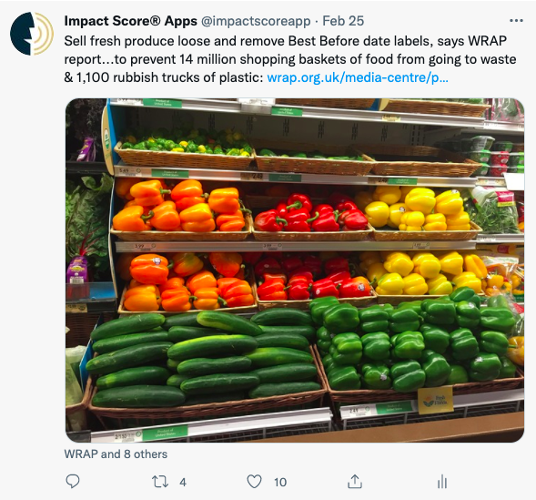
- Facebook: Impact Score App
- Insta: impactscoreapp
- LinkedIn: Impact Score App
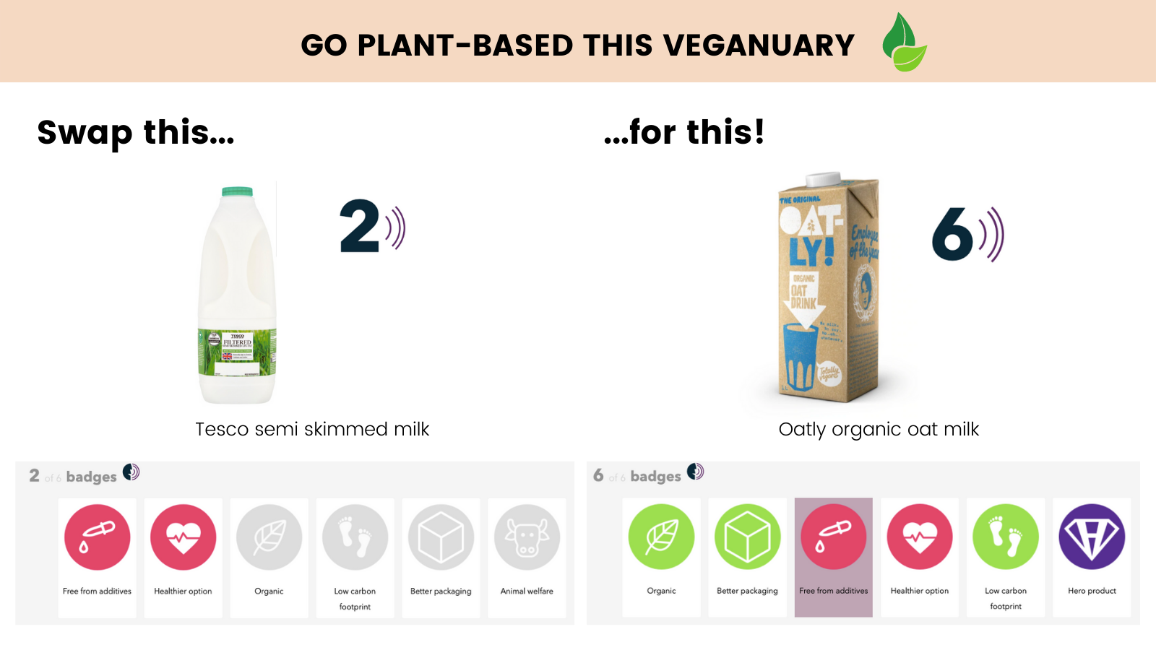

5. BLOGS FOR USE
We’re always working on new, topical blogs. We’re happy for you to use these - but do let us know what you’re using and where, and credit us.
Blogs page>

6. PRESS COVERAGE
We’ve been in the press quite a bit of late! Here’s some links to some of our most interesting pieces of coverage, they might spark content ideas for you!

- Food Navigator ‘Consumers want more than a simple score: Behind the app rating the sustainability of products and their makers’, 28 Jan 2022
- The Guardian ‘Toxic reaction: how to clear dangerous pollutants out of your home’ , 16 Jan 2022
- The Times ‘Could this scanner app change my unhealthy eating habits?’, 13 Jan 2022
- The Guardian ‘My week as a Climatarian’, 10 Nov 2021
- The Grocer Magazine ‘The new apps swaying consumer food choices’, 15 August 2021
- FMCG Magazine ‘Leading consumer impact apps untie to accelerate ethical change in UK retail sector’, 9 July 2021

